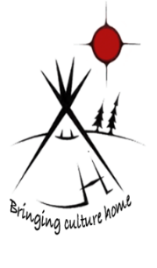Tipi Moza (Iron Homes)
1422-993 Princess Street, Unit 14, Kingston, ON K7L 1H3
Phone: 613-547-1134 Fax: 613-507-7267

Self-Declaration of Eligibility

Ancestry Claim:

In Canada there are 316 Registered First Nation Territories. In this form we kindly ask you to declare your First Nation affiliation region/territory within Canada. The information you provide on the document collected is under the authority of Tipi Moza (Iron Homes) for the purpose of verifying eligibility under the Urban Housing Program. Please fill out one row declaring your ancestry to be eligible for vacancies with Tipi Moza (Iron Homes).

I certify that I am:

Affiliation | Full Name(s) | Territory/ Region | Band #
Status/ Registered

Non- Status

Innuit

Metis

Additional Comments:

All the information I have given is true and complete and may be verified.

Name: ______________________________

Signature: ______________________________ Date: ________________________________

